# Overview

## Introduction

Document management system is designed to organize projects, business files and records digitally, whether they started out in paper form or were generated by software applications. Paper files are first converted to electronic format by scanning. This provides a more compact means of storage, our system will provide for each role lots of way to interact. For example, a guest will be able to view the public file, if you are a registered user, you will have tons of ways to play around with our system, for example you can view, create or upload, delete or update a folder, you can also do the same with files. And there is an admin who can manage all the account in the system.

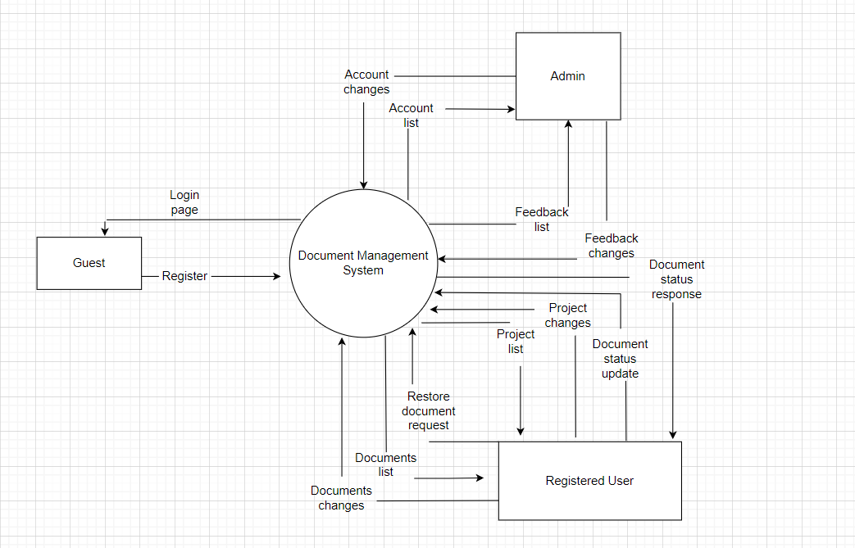

## System Functions

### Screen Flow

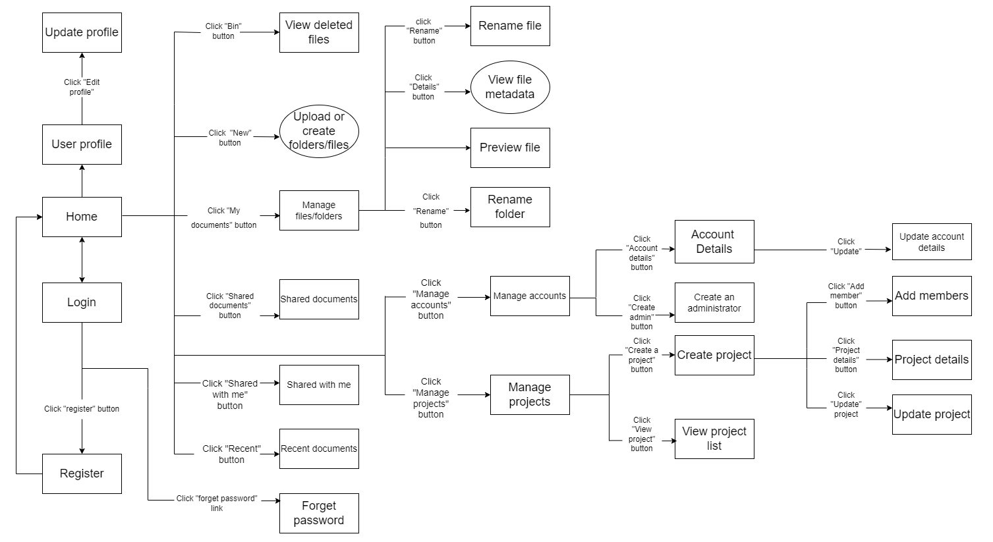

### Screen Details

|  |  |  |  |
| --- | --- | --- | --- |
| **#** | **Feature** | **Screen** | **Description** |
| 1 | Authentication | Home | Show documents, options for each role |
| 2 | Authentication | Login | Allow users to type in their username, password |
| 3 | Authentication | Register | Create new users |
| 4 | Authentication | Forget password | Allow users to recover their password |
| 5 | Authentication | reCapcha | Check reCapcha |
| 6 | Account management | View user profile | Show all users’ information |
| 7 | Account management | Update profile | Allow users to change their profile |
| 8 | Account management | View account list | Show all the accounts have been registered |
| 9 | Account management | Search accounts | Allow administrator to search for a specific account |
| 10 | Account management | Account details | Show admin the details of selected account |
| 11 | Account management | Create administrator | Allow admin to create an account |
| 12 | Account management | Assign Administrator | Allow admin to assign his/her role to a user |
| 13 | Account management | Update account details | Allow admin to update the information of selected account |
| 14 | Account management | Assign Administrator role | Assign a user to become an administrator |

# Architecture model:

## Class diagram: